**PRAKTIKUM WEB 2**

**BAB 6**

Nama :Muhammad Rangga Cahaya Putra

Nim :112210032

Kelas :TI 5A

* **Data base**

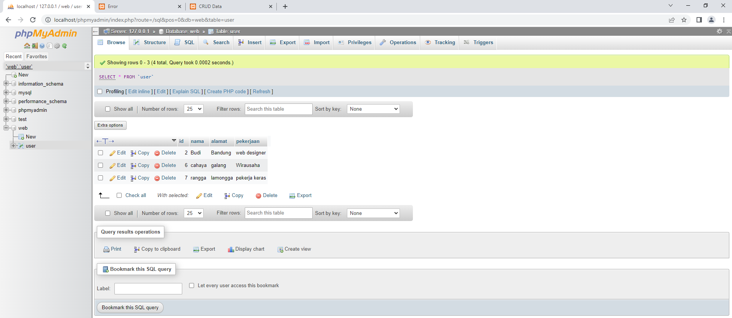

* **Konfig data base.php**

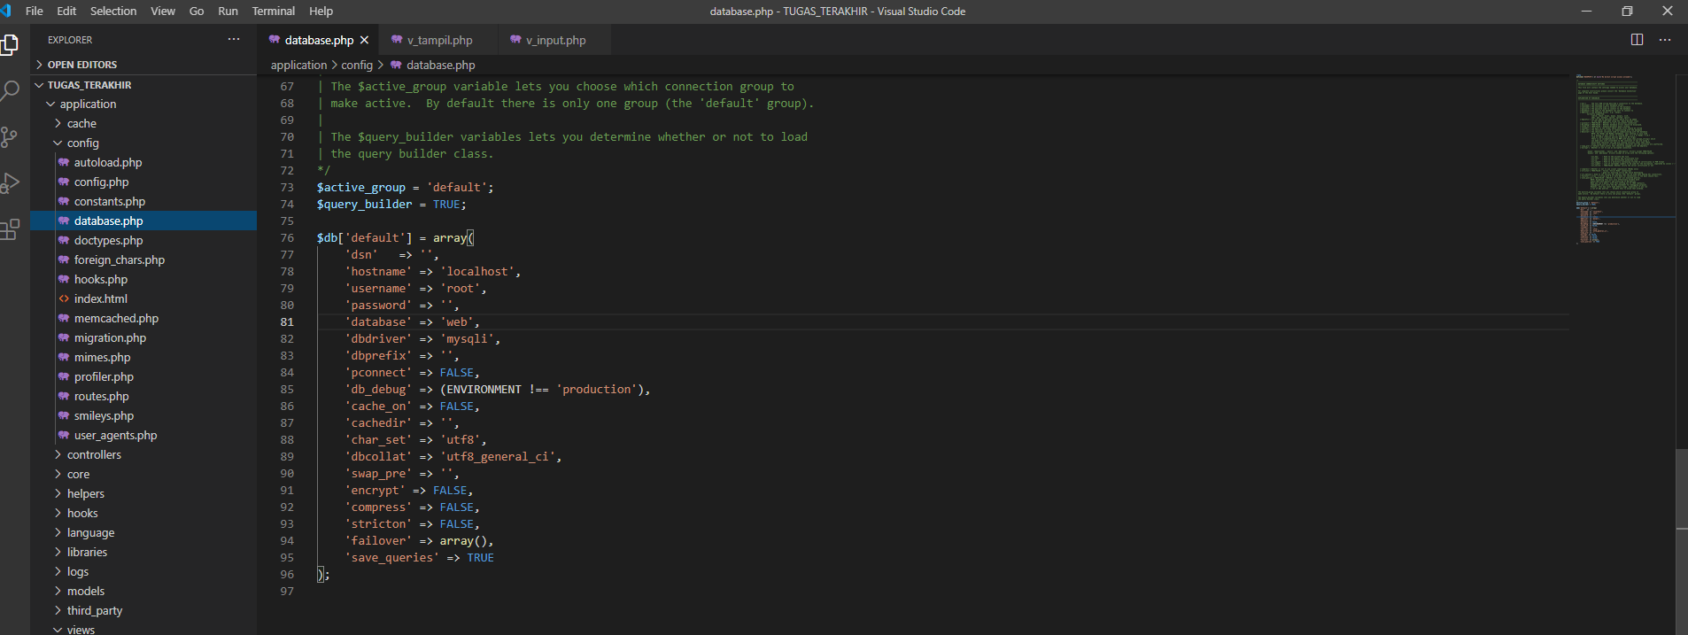

* **Tampilan crud.php**

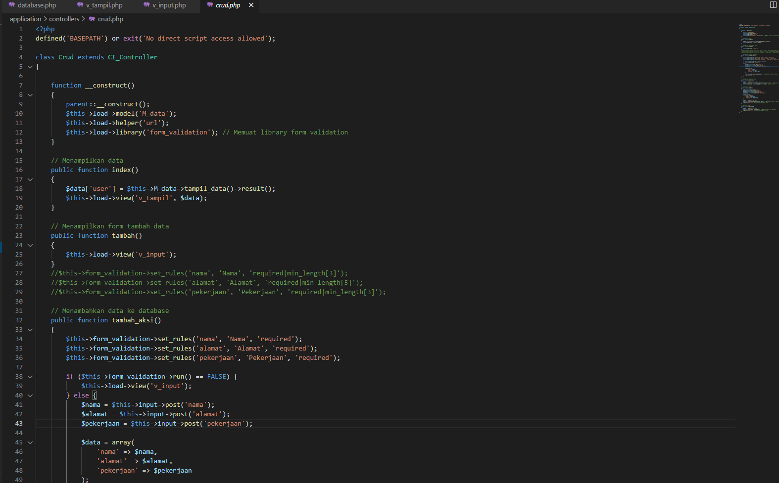

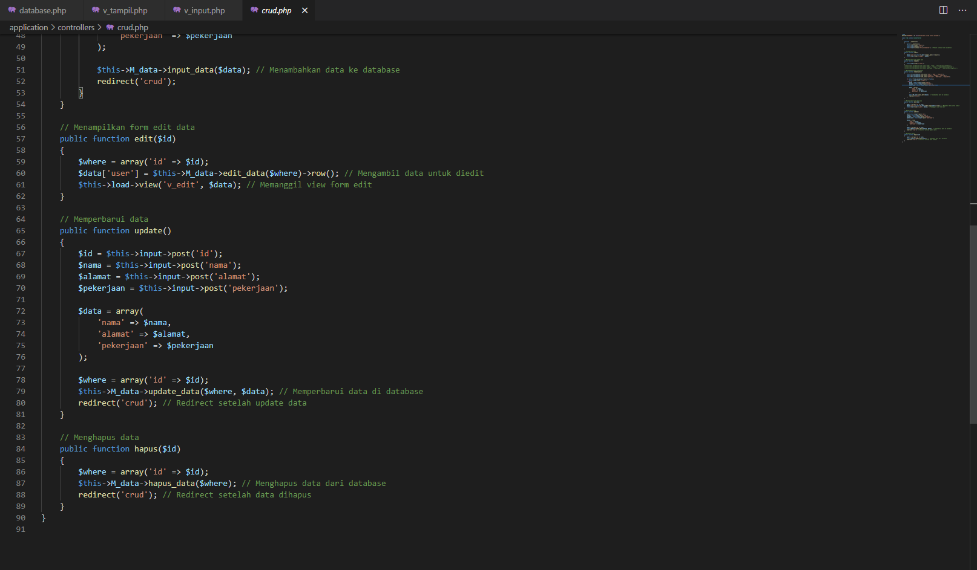

* **Tampilan autoload.php**

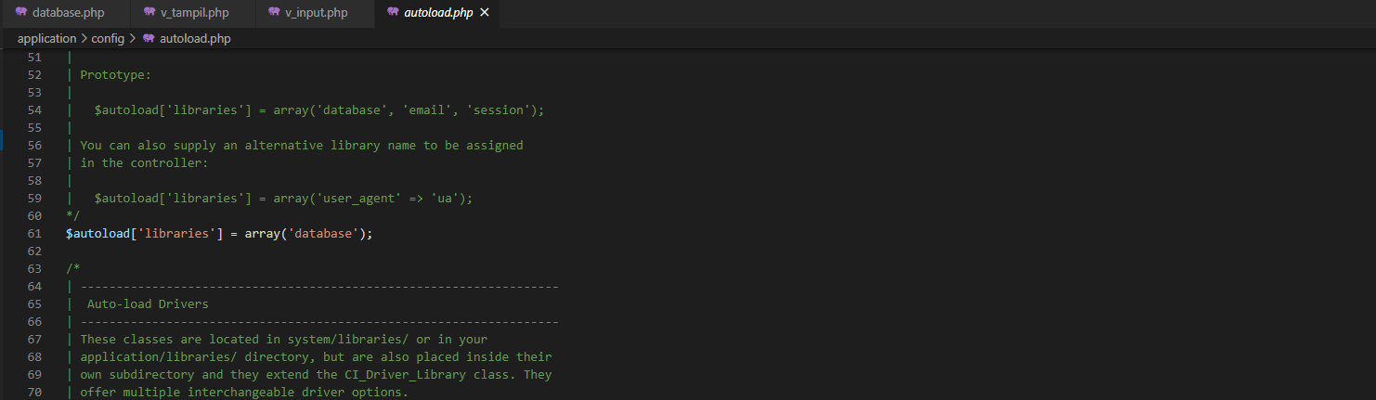

* **Tampil M_data.php**

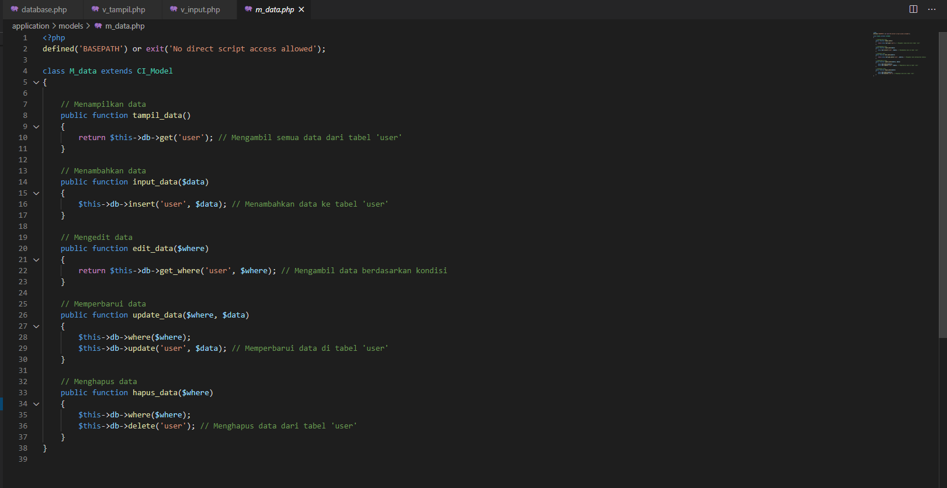

* **View edit.php**

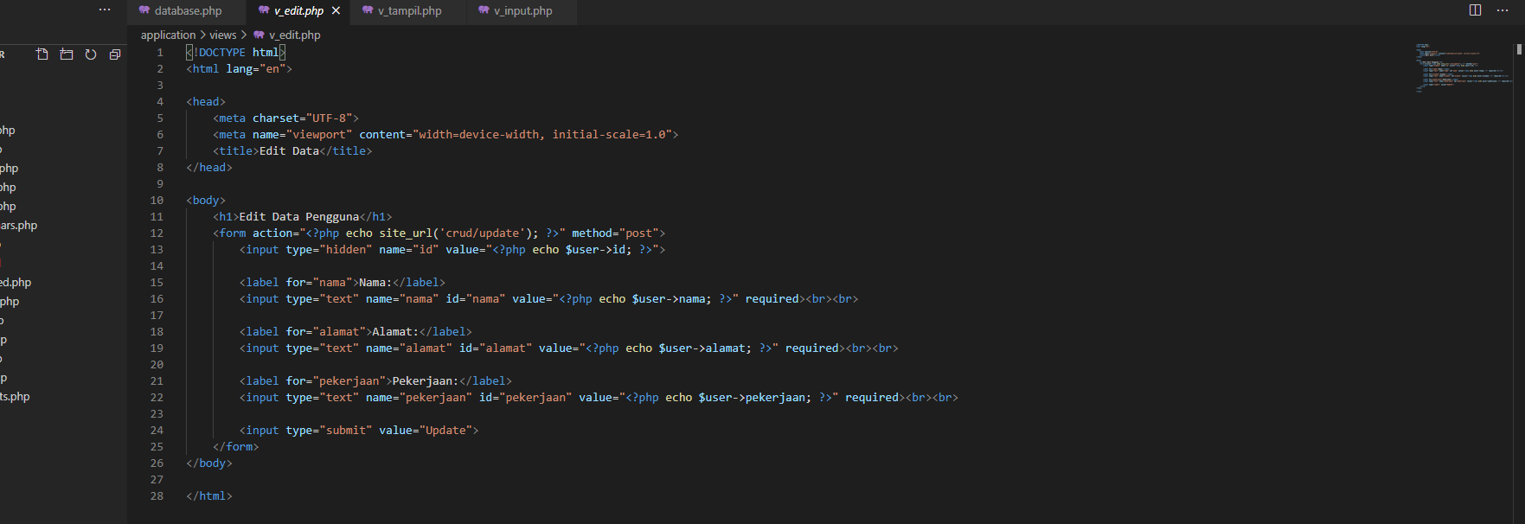

* **View tampil.php**

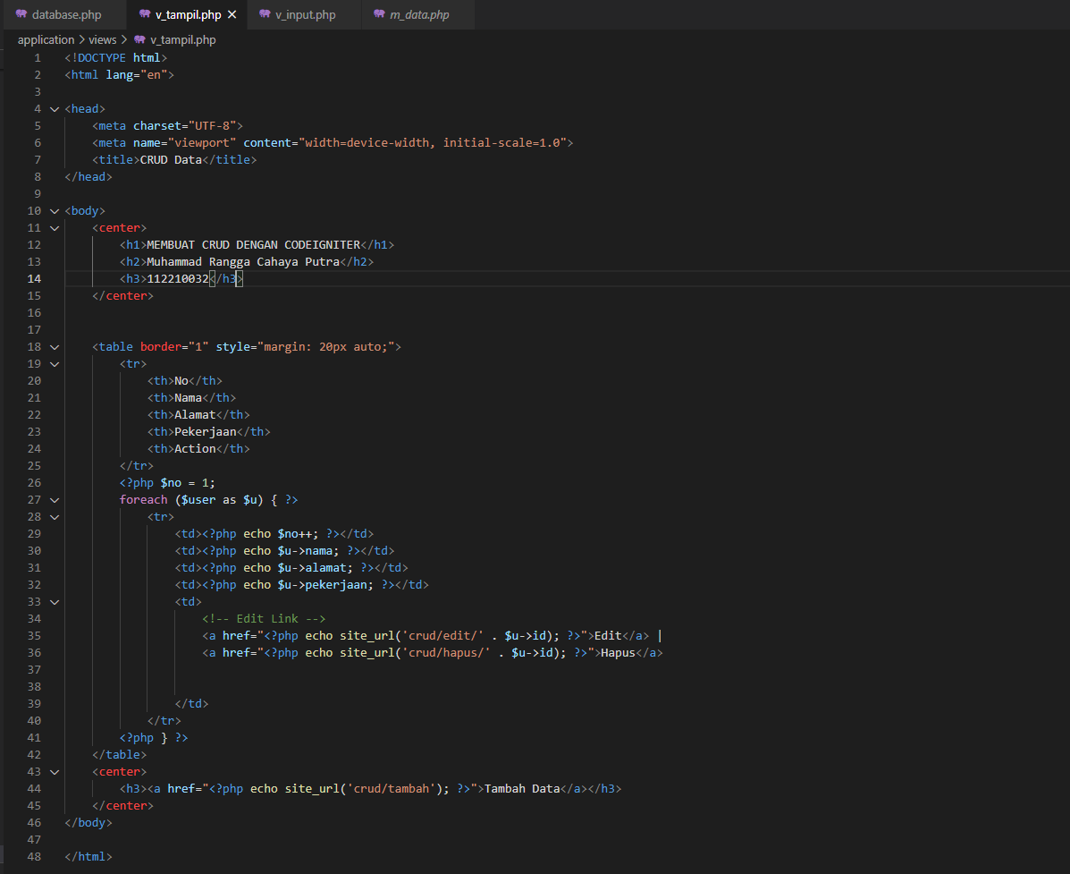

* **View input.php**

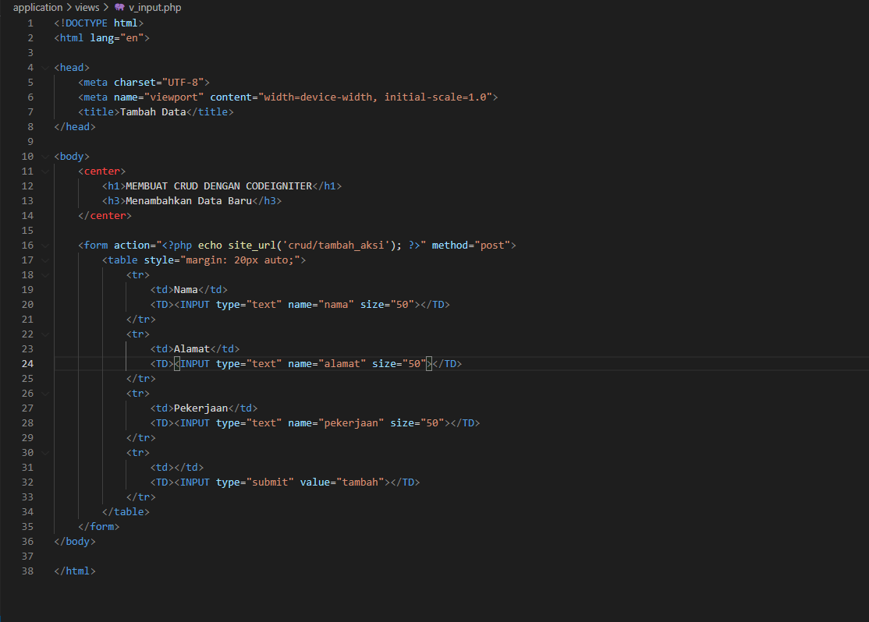

* **Tampilan utama**

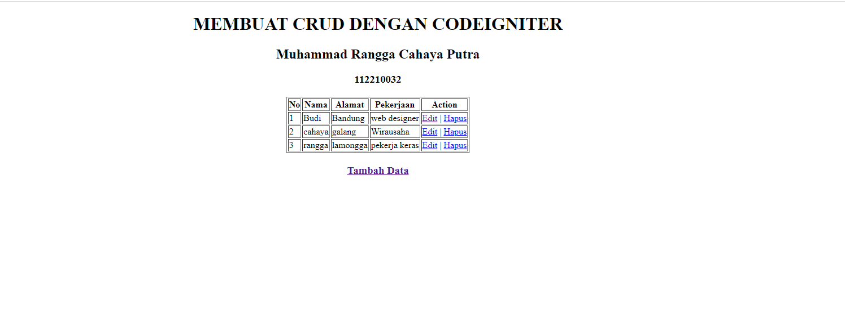

* **Tampilan tambah data**

